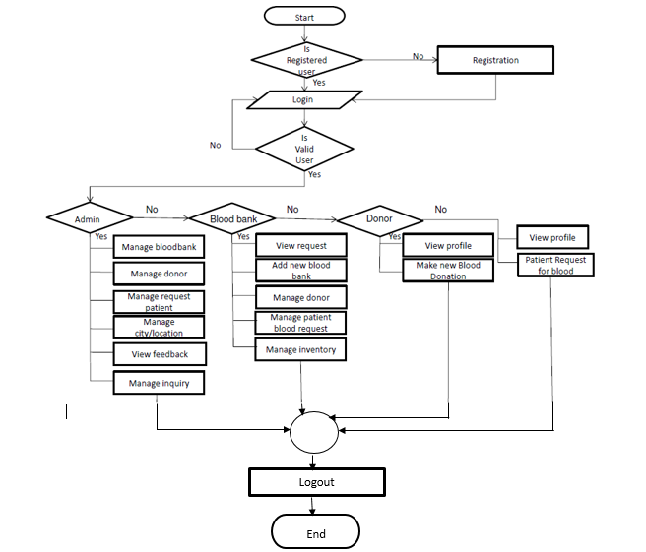

Object

Diagram

Diagram

Sequence

Diagram

Collaboration

Diagram

Behaviour

Diagram

Activity

Diagram

Interaction

Diagram

Use Case

Diagram

Deployment

Diagram

Class

Diagram

Structure

Diagram

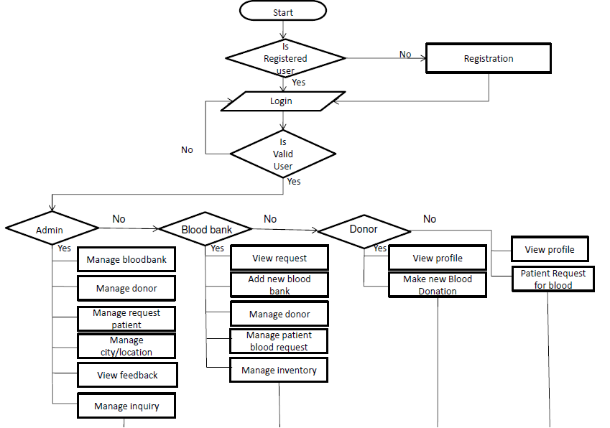

End

Logout